Chapter XIV

Focus on OOP, Polymorphism

Chapter XIV Topics

14.1 Introduction
14.2 Overloaded Operators and Methods
14.3 Polymorphism with an Interface
14.4 Polymorphism with a Superclass
14.5 Interface or Superclass?
14.6 How Does Polymorphism Work
14.7 The Choo-Choo Train Inheritance
14.8 A Polymorphic Choo-Choo Train
14.9 Summary

14.1 Introduction

This chapter will be an introduction on an Object Oriented Programming topic that is easily misunderstood or ignored. The topic in this chapter is particularly important for a complete understanding of Object Oriented Design that is covered later and for students taking the AP Examination.

The title of this chapter is probably intimidating. A word like polymorphism is not part of the typical vocabulary used by high school students. So right now let us examine this word before you look at some Java program examples.

Polymorphism is not part of any teenage vocabulary. I doubt if it is part of any adult's vocabulary, if you do not include computer scientists who use Object Oriented Design. Strange as this word may seem, you are familiar with parts of the word. You know that polygon means many sides. In today's special effects movies you have also become aware of morphing. You see images that change from one shape to another shape. The word morph means form or shape and polymorphism means many forms.

Computer science, like many disciplines, takes vocabulary that already exists and provides its own unique meaning. The brief paragraph presented was meant to give some clarification on the meaning of polymorphism. Hopefully, some understanding of the word origins will assist in understanding the use in computer science. Now knowing what polymorphism means does not clarify what its purpose is in any computer science curriculum.

You have already learned and used OOP concepts for quite some time. In the early introduction of OOP you learned that OOP is a style of programming that uses encapsulation, class interaction and polymorphism. Of these three OOP features, you now take a closer look at polymorphism.

At all times remember that the primary goal of Object Oriented Programming is reliability. Take a quick reliability inventory that you have learned so far with OOP. The first OOP focus was on encapsulation. With encapsulation all the data and the procedures - called methods in Java - that access the data are placed in the same module or class. Special care is taken that access to the data is controlled in such a manner that unwanted side effects are avoided. This increases reliability.

The second stage of OOP focus is class interaction. Reliability is acquired here by using classes that already exist. Ideally, such classes have been tested and improved and then can be used in other programs. Class interaction has two divisions and both improve reliability by using existing, finished classes. The first one is inheritance¸ which uses an is-a relationship. With inheritance a new class is created that uses features from an existing superclass and then re-defines or newly-defines one or more methods. The second class-interaction is composition, which uses a has-a relationship. With composition a new class is created, which uses - as part of the new class - data attributes that are objects of an existing class or classes.

Now we come to the third Focus on Object Oriented Programming and it is called polymorphism, which means many forms. If each OOP focus can justify its existence with the explanation of programming reliability then polymorphism should once again improve our programs. This is true and in the case of polymorphism reliability is improved by making an object responsible for its own actions. This probably means precisely nothing to you right now.

Consider the opening night of your high school’s theatre performance of Beauty and the Beast. Lots of nervous students stand behind the stage ready to perform their particular part in the play. Months of practice are about to be tested. What is the job of the theater arts teacher? He or she made sure that each student knows exactly how his or her character has to act. At opening night the teacher does not nervously run around and tells everybody what to do. No, as the curtain is about to go up every student is told to go out there and act. This actually is a curious statement because each student has a different role. That means that the statement go out there and act has a different meaning for every person. The verb is the same, but the reliability of the play’s success is based on every student being prepared to do act the role of a different character. If this was done during the actual play, the teacher would go crazy, the students would be nervous wracks and the play would likely be a disaster.

In a nutshell that is the essence of polymorphism. You call a method, like qwerty and this method has the exact same name in many different classes, but the method definition is different in each class. Yet when the method is called, it magically performs its job correctly, according to the definition found in its own class. Like the student at Beauty and the Beast every class object is responsible for their own actions. How a computer program manages to do this correctly is the teaching goal of this chapter.

14.2 Overloaded Operators and Methods

There are some debates about polymorphism that are addressed in this section. The debate concerns overloaded operators and overloaded methods. Is that polymorphism? The answer to the question will come somewhat later after you have seen a couple of programs that clarify the concern.
Program Java1401.java, in figure 14.1 features two int variables and two String variables. This goes back to the beginning of the textbook where you learned about the difference between addition and concatenation. The main point of this program is to illustrate that the exact same plus < + > operator performs two completely different functions, which are addition and concatenation. It is then stated that the plus operator is overloaded.

Addition and Concatenation
100 + 200 = 300 (this is addition)

“100” + “200” = “100200” (this is concatenation)

Figure 14.1
// Java1401.java
// The < + > operator in Java is overloaded.
// This program shows that the same operator can perform
// arithmetic addition and string concatenation.
public class Java1401
{
public static void main (String[ ] args)
{
int n1 = 1000;
int n2 = 2000;
int n3 = n1 + n2;
String s1 = "1000";
String s2 = "2000";
String s3 = s1 + s2;
System.out.println("n1 + n2 = " + n3);
System.out.println();
System.out.println("s1 + s2 = " + s3);
System.out.println();
}
}

Figure 14.1 Continued
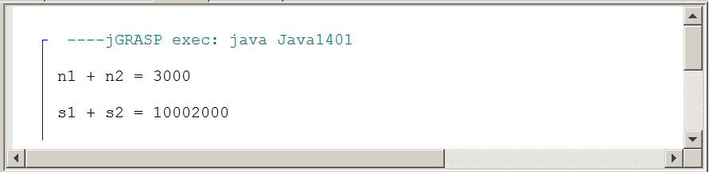

There is no argument that the plus operator performs two different functions and there is no argument that this operator is called overloaded. Does this mean that the plus operator is an example of polymorphism? If polymorphism means many forms and the plus operator takes on two different forms then is the natural conclusion that you are observing one example of polymorphism?

The answer to this question has to do with the literal meaning of polymorphism and the "intended" meaning. In the literal sense the plus operator has many forms, hence it is polymorphism. End of discussion and there is no debate. That is short and simple, but as one of the corner stones of Object Oriented Programming the plus operator does not qualify. OOP was developed to create more reliable programs. In this spirit each main branch or corner stone of OOP can point to increased reliability. In all honesty does our humble plus operator add reliability to a program, because it has the ability to perform two different functions?

Consider program Java1402.java, in figure 14.2, as another potential example of polymorphism. This program has four nifty drawSquare methods that are quite identical in nature, but they have four different names and sets of parameters. The output display shows four lovely squares. Figure 14.2 shows a program with four similar, but different methods. The method identifiers all share the drawSquare identifier part, but then they are followed by four different set of parameters. You are looking at similar methods, but not identical methods, so this program is off the table for a polymorphism example.

Figure 14.2
// Java1402.java
// This program draws four squares with four different
// <drawSquare> methods.
// There are no overloaded methods.
import java.awt.*;
import java.applet.*;
public class Java1402 extends Applet
{
public void paint(Graphics g)
{
drawSquare1(g);
drawSquare2(g,200,300);
drawSquare3(g,Color.blue,600,200);
drawSquare4(g,Color.green,500,400,200);
}
public void drawSquare1(Graphics g)
{
g.setColor(Color.black);
g.fillRect(100,100,150,150);
}
public void drawSquare2(Graphics g, int x, int y)
{
g.setColor(Color.red);
g.fillRect(x,y,150,150);
}
public void drawSquare3(Graphics g, Color color, int x, int y)
{
g.setColor(color);
g.fillRect(x,y,150,150);
}
public void drawSquare4(Graphics g, Color color, int x, int y, int side)
{
g.setColor(color);
g.fillRect(x,y,side,side);
}
}

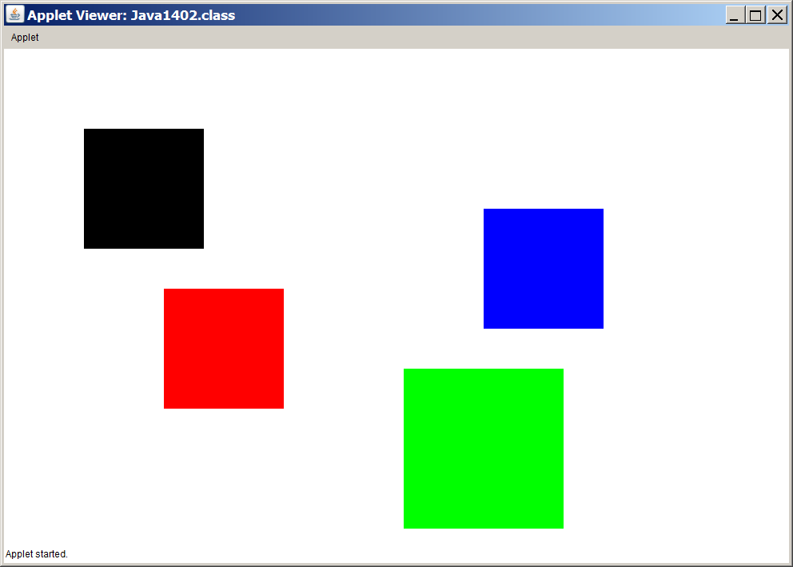
Program Java1403.java, in figure 14.4, produces the exact same output as the previous program. The two programs are very similar and close inspection of the two paint methods in figure 14.3 shows both the subtle difference and similarity. Java1403.java shows four drawSquare methods with the exact same identifier. The four different sets of parameters still exists, but the four methods are undeniable identical in name. This is a case of four overloaded methods. Java has no difficulties handling methods with identical identifiers, because Java considers the method signatures, which is a combination of identifier and parameters. Simply put, overloaded methods have the same name, but different signatures. Calling such methods overloaded brings no debate. We have four identical methods that appear to take on four different forms. Same question. Is this an example of polymorphism? Same answer as for the plus operator. In the literal sense yes, and in the OOP spirit and reliability no.

Figure 14.3
Java1402.java paint method
public void paint(Graphics g)
{
drawSquare1(g);
drawSquare2(g,200,300);
drawSquare3(g,Color.blue,600,200);
drawSquare4(g,Color.green,500,400,200);
}

Java1403.java paint method

public void paint(Graphics g)
{
drawSquare(g);
drawSquare(g,200,300);
drawSquare(g,Color.blue,600,200);
drawSquare(g,Color.green,500,400,200);
}

Figure 14.4
// Java1403.java
// This program draws four different squares with the
// same <drawSquare> method name.
// Each method has a different parameter signature.
// These are overloaded methods.
import java.awt.*;
import java.applet.*;
public class Java1403 extends Applet
{
public void paint(Graphics g)
{
drawSquare(g);
drawSquare(g,200,300);
drawSquare(g,Color.blue,600,200);
drawSquare(g,Color.green,500,400,200);
}
public void drawSquare(Graphics g)
{
g.setColor(Color.black);
g.fillRect(100,100,150,150);
}
public void drawSquare(Graphics g, int x, int y)
{
g.setColor(Color.red);
g.fillRect(x,y,150,150);
}
public void drawSquare(Graphics g, Color color, int x, int y)
{
g.setColor(color);
g.fillRect(x,y,150,150);
}
public void drawSquare(Graphics g, Color color, int x, int y, int side)
{
g.setColor(color);
g.fillRect(x,y,side,side);
}
}

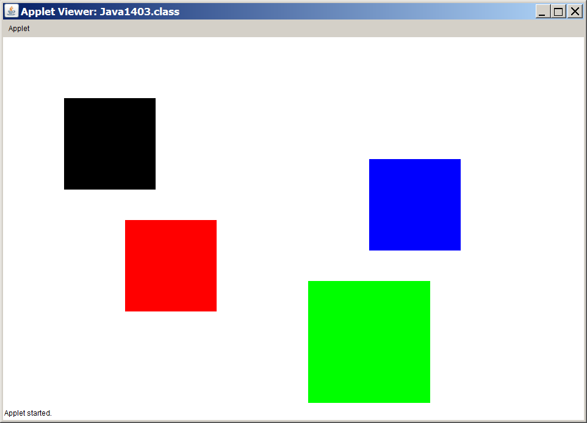
Some readers may be frustrated. Two program examples show evidence of many forms and have an argument that polymorphism exists. In both cases the question is does it satisfy the spirit of polymorphism in OOP? Personally, I do not care so much for these types of debates. It is very easy for me to accept that the two previous program examples do have many forms and thus qualify for polymorphism. It is also easy for me to accept that there is some OOP component-intended-meaning of polymorphism that is not satisfied. Some of the more research-oriented students will state that these are examples of early polymorphism and late polymorphism. Yes, yes and this gets into binding and other stuff, but it still does not satisfy the OOP intention.

The real importance in my humble opinion is not to get overly excited over the precise meaning of a term, like polymorphism. If you understand that an operator, like plus, can be overloaded and that methods, including constructors, can also be overloaded, then we can get down to the business of this chapter. The remainder of this chapter will concentrate of explaining how to use polymorphism in the Object Oriented Programming sense, in other words how do we use polymorphism to increase program reliability?

14.3 Polymorphism with an Interface

Umbrella in computer science means something quite different from a device to keep the rain off your head. In computer science you may observe that the class identifier is different from the constructor identifier. Figure 14.5 shows four program statements. Four new objects are declared with the same Language interface identifier, but instantiated with four different constructor identifiers. In this case the Language interface is considered the umbrella. This is one of these Schram words that may not be officially recognized by the computer science community, but it sure helps me to explain concepts in my classroom.

Figure 14.5
Language obj1 = new English();
Language obj2 = new German();
Language obj3 = new Dutch();
Language obj4 = new French();

This umbrella concept is all around us in regular English. Before the start of a high school pep rally, a principal may state that at 10:00am all students go to the main gymnasium. After that statement the principal can continue and explain that the 9th graders and 10th graders sit on the north side and the 11th graders and 12th graders sit on the south side. The point here is that it is not necessary to start the announcement and then say:

9th graders go to the gymnasium at 10:00am.
10th graders go to the gymnasium at 10:00am.
11th graders go to the gymnasium at 10:00am.
12th graders go to the gymnasium at 10:00am.

In this example students is the umbrella that four types of students fit under.

All students go to the gymnasium at 10:00am.

There exist many umbrella terms that you hear frequently in English, like:

All athletes meet with the athletic director after school on the football field.
Non-US Citizens need to check with immigration on the left-side lanes.
Drunk drivers will be arrested on the spot.
Parents are encouraged to come to "meet the teachers night."
All Richardson ISD teachers start the year at the superintendent's convocation.
After the convocation Berkner HS teachers return in the first two busses.
The Berkner HS math department will have a meeting tomorrow morning.

The last three statements give instructions to teachers of the Richardson ISD. Notice how the umbrella class tends to be as large as is necessary. For the convocation the umbrella is the Richardson teachers. Bus transportation uses a single-school umbrella. Once at Berkner High School the umbrella is now limited to the math teachers only.

This is not some weird tangent unrelated to the subject at hand. The concept of the umbrella class is the foundation of polymorphism. However, the umbrella and polymorphism will not be used initially. We will look at a sequence of programs that will slowly progress into polymorphism and demonstrate this important third stage of Object Oriented Programming. Program Java1404.java, in figure 14.6, is meant to make sure that you are not confused. Here is a program with multiple classes and each class has a method, called greeting. Each greeting method displays what is appropriate for a certain language. In this example the greeting method is not overloaded;there is not an umbrella class and there is no polymorphism.

Figure 14.6
// Java1404.java
// This program displays the output of four different classes
// with the same <greeting> method.
// This program uses neither inheritance nor polymorphism.
public class Java1404
{
public static void main (String[ ] args)
{
English g1 = new English();
German g2 = new German();
Dutch g3 = new Dutch();
French g4 = new French();
g1.greeting();
g2.greeting();
g3.greeting();
g4.greeting();
}
}
class English
{
public void greeting() { System.out.println("In English you say Good Day"); }
}
class German
{
public void greeting() { System.out.println("In German you say Guten Tag"); }
}
class Dutch
{
public void greeting() { System.out.println("In Dutch you say Goeden Dag"); }
}
class French
{
public void greeting() { System.out.println("In French you say Bonjour"); }
}

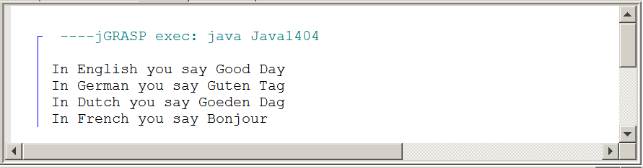

Program Java1405.java, in figure 14.7, uses a Language interface with a greeting method. This is still not polymorphism, but we are closer. The format in this program is a little different. Java does not care and it helps to fit on the page.

Figure 14.7
// Java1405.java
// This program uses a <Language> interface with four implementing classes.
public class Java1405
{
public static void main (String[ ] args)
{
English g1 = new English();
German g2 = new German();
Dutch g3 = new Dutch();
French g4 = new French();
g1.greeting(); g2.greeting(); g3.greeting(); g4.greeting();
}
}
abstract interface Language
{
public abstract void greeting();
}
class English implements Language
{
public void greeting() { System.out.println("In English you say Good Day"); }
}
class German implements Language
{
public void greeting() { System.out.println("In German you say Guten Tag"); }
}
class Dutch implements Language
{
public void greeting() { System.out.println("In Dutch you say Goeden Dag"); }
}
class French implements Language
{
public void greeting() { System.out.println("In French you say Bonjour"); }
}

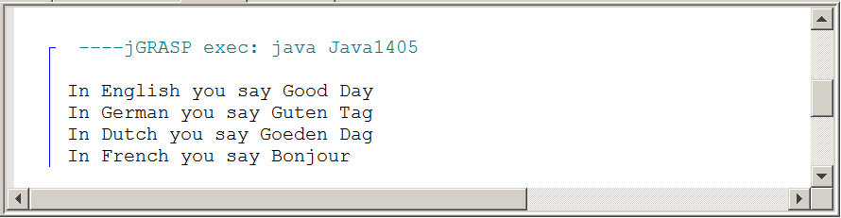
Program Java1406.java, in figure 14.8, introduces a printGreeting method. This method is plain awful. We have objects, from the English, German, Dutch and French classes that are passed as parameters to the printGreeting method. Since we use the Object class there will be no problems using objects from different classes. The Object class is the superclass of all Java classes and we can say it is the umbrella class for all classes. This program does not display the four individual classes for each one of the languages. They are included with your actual Java programs in a separate folder.

Figure 14.8
// Java1406.java
// In this program a very convoluted method is
// used to print the greeting for each language.
public class Java1406
{
public static void main (String[ ] args)
{
English g1 = new English();
German g2 = new German();
Dutch g3 = new Dutch();
French g4 = new French();
printGreeting(g1);
printGreeting(g2);
printGreeting(g3);
printGreeting(g4);
}
public static void printGreeting(Object g)
{
if (g instanceof English)
{
English temp = (English) g;
temp.greeting();
}
else if (g instanceof German)
{
German temp = (German) g;
temp.greeting();
}
else if (g instanceof Dutch)
{
Dutch temp = (Dutch) g;
temp.greeting();
}
else if (g instanceof French)
{
French temp = (French) g;
temp.greeting();
}
}
}

Figure 14.8 Continued
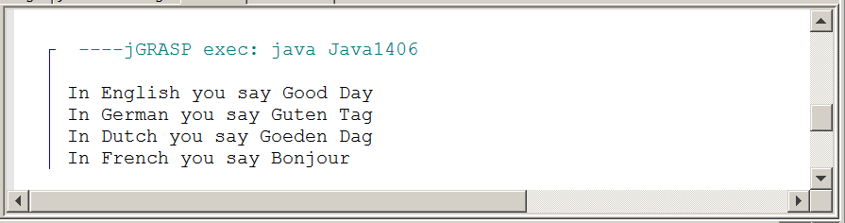

The printGreeting method of the previous program is an example of a bad method that uses a bunch of convoluted code to function properly. There are multiple if (g instanceof some class) statements to determine the class of the object. This helps to determine how to cast the object to the proper class.

There is a purpose with the bad printGreeting method. It shows that much work is done to make the program execute correctly. There are four different language objects and four different greeting methods in this program. With a single method to print the greetings, a bunch of control structures are needed.

The next program example will show a nice short, simple method that takes care of our greeting needs, and yes it finally uses polymorphism. First, we need to look at figure 14.9 and check out the Language umbrella interface. There it is. The Language interface is the umbrella for English, German, Dutch and French. Each of the four concrete classes implements the abstract interface Language. We need such an umbrella interface for the polymorphism business to work. We also need a polymorphic method. The polymorphic greeting method needs to be in the umbrella interface. Then each one of the concrete classes will implement the greeting method according to its own requirements.

Figure 14.9
Language g1 = new English();
Language g2 = new German();
Language g3 = new Dutch();
Language g4 = new French();

abstract interface Language
{
public abstract void greeting();
}

Finally, program Java1407.java, in figure 14.10, shows polymorphism and this is done with a very simple printGreeting method. Note that the parameter type in the printGreeting heading is Language. You need that umbrella interface.

Figure 14.10
// Java1407.java
// This program uses polymorphism with a very simple <printGreeting> method.
// The <Language> interface is the "umbrella".
public class Java1407
{
public static void main (String[ ] args)
{
Language g1 = new English();
Language g2 = new German();
Language g3 = new Dutch();
Language g4 = new French();
printGreeting(g1);
printGreeting(g2);
printGreeting(g3);
printGreeting(g4);
}

public static void printGreeting(Language obj)
{
obj.greeting();
}
}
abstract interface Language
{
public abstract void greeting();
}
class English implements Language
{
public void greeting() { System.out.println("In English you say Good Day"); }
}
class German implements Language
{
public void greeting() { System.out.println("In German you say Guten Tag"); }
}
class Dutch implements Language
{
public void greeting() { System.out.println("In Dutch you say Goeden Dag"); }
}
class French implements Language
{
public void greeting() { System.out.println("In French you say Bonjour"); }
}

Figure 14.10 Continued
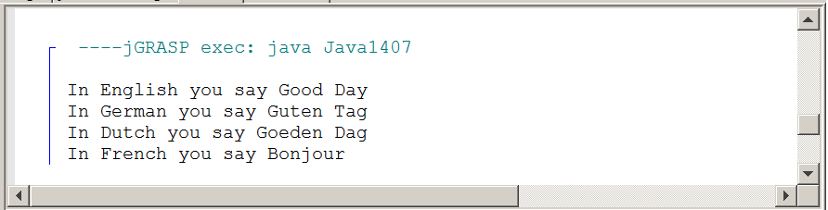

So what is the polymorphism part? The secret is in the printGreeting method. Look at it again in figure 14.11, you will see the method show up in three places. The greeting method starts as an abstract method in the Language interface. The concrete classes that implement Language (English, German, Dutch, French) are each required to implement the greeting method. Each concrete class uses the exact same heading and then implements the method according to its own language greeting.

Figure 14.11
public static void printGreeting(Language obj)
{
obj.greeting();
}
abstract interface Language
{
public abstract void greeting();
}
class English implements Language
{
public void greeting()
{
System.out.println("In English you say Good Day");
}
}
There are several ways to implement polymorphism. The previous program uses a printGreeting method to handle polymorphism. This method receives parameter information and the data type of the parameter is the Language interface umbrella implemented by all the concrete classes.

The next program uses another approach, which is quite popular. Java1408.java, in figure 14.12, repeats the language program. The output of the program is identical, but there is no printGreeting method. This time you will see that a generic array of the ArrayList class is used.

The data type of the generic array is Language, our trusty interface umbrella. A generic class restricts new elements to its declared data type. If this data type is an umbrella interface then the rule is not violated.

Consider an assembly in a high school gymnasium. The principal can make the following statements to clarify who should go to the assembly:

All students need to go to the assembly in 10 minutes.
All athletes need to go to the assembly in 10 minutes.
All football players need to go to the assembly in 10 minutes.
All Varsity foot players need to go to the assembly in 10 minutes.
All Senior Varsity Football players need to go to the assembly in 10 minutes.

Did you notice how the umbrella started with a substantial group. It is a very large umbrella with all students. Each statement that follows makes the umbrella smaller, but it still is an umbrella identifying a specific subgroup of students. Consider a generic class with the following declaration:

ArrayList<Integer> numbers = new ArrayList<Integer>();

numbers is quite a restrictive array and might be precisely what the intend of a programmer is. On the other hand, consider the follow second declaration:

ArrayList<Language> obj = new ArrayList<Language>();

The second declaration uses the interface Language, which means that an object of any concrete class implementing Language can become an element of this array. If the program adds additional classes and these future classes all implement the Language interface they can also become members of the array.

This array approach to use polymorphism is precisely what you will see in figure 14.12. The Language interface and each of its four implementing concrete classes are the same as the previous program and will not be shown again.

Figure 14.12
// Java1408.java
// This program uses polymorphism in a different way.
// The "umbrella" <Language> is now used as the element for an <ArrayList> object.
import java.util.ArrayList;
public class Java1408
{
public static void main (String[ ] args)
{
Language g1 = new English();
Language g2 = new German();
Language g3 = new Dutch();
Language g4 = new French();
ArrayList<Language> languages = new ArrayList<Language>();
languages.add(g1);
languages.add(g2);
languages.add(g3);
languages.add(g4);
for (Language language : languages)
language.greeting();
}
}

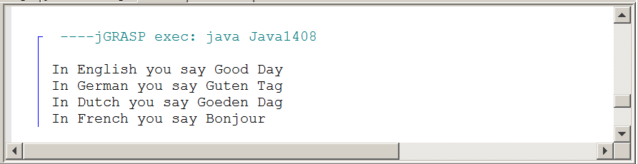

14.4 Polymorphism with a Superclass

Whenever many examples are provided in the same manner it can quickly give the impression that this is how something must be done. In other words, there are so many examples on our Internet showing interface examples of polymorphism that it may well seem that an interface is a polymorphism requirement. This is not true. The requirement is to use an umbrella interface or an umbrella superclass. Do you see why this is such a neat word? If you encounter a future college professor who wonders about your computer science vocabulary, just tell the professor that you used a textbook by a crazy high school teacher, called Leon Schram, who has a habit of making up his own words to clarify topics.

So what are the ingredients to make this polymorphism thing work in Java? Well, first there is the umbrella, which in the last section is an interface. Apparently it can be something else, but we still do need an umbrella. The second very important part is the polymorphic method. This is the method with the exact same signature in all the different concrete classes. This polymorphic method must also show up in the umbrella. The third part is a different implementation of the polymorphic method for each different concrete class. If we follow these rules then check out program Java1409.java, in figure 14.13. The testing class looks very familiar and then it changes. There is now an abstract Language class.

Figure 14.13
// Java1409.java
// In this program polymorphism is achieved using
// an abstract superclass as the umbrella.
public class Java1409
{
public static void main (String[ ] args)
{
Language g1 = new English();
Language g2 = new German();
Language g3 = new Dutch();
Language g4 = new French();
printGreeting(g1);
printGreeting(g2);
printGreeting(g3);
printGreeting(g4);
}
public static void printGreeting(Language obj)
{
obj.greeting();
}
}
abstract class Language
{
public abstract void greeting();
}
class English extends Language
{
public void greeting()
{
System.out.println("In English you say Good Day");
}
}
class German extends Language
{
public void greeting()
{
System.out.println("In German you say Guten Tag");
}
}
class Dutch extends Language
{
public void greeting()
{
System.out.println("In Dutch you say Goeden Dag");
}
}
class French extends Language
{
public void greeting()
{
System.out.println("In French you say Bonjour");
}
}

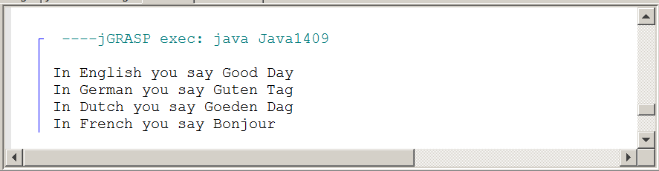

The superclass and the four concrete classes are shown. They are very similar, perhaps even identical in appearance, but note that each class extends and not implements. They are subclasses of superclass Language. The result appears to be the same. A later section in this chapter explains when polymorphism should use an interface and when it should use a superclass.
You have seen polymorphism with an interface umbrella. You have seen polymorphism with an abstract superclass umbrella. There is one more that needs to be shown and that is the concrete superclass umbrella. Java1410.java, in figure 14.14. shows the third polymorphism approach. The four concrete classes are identical to the previous program. They extend the Language superclass. The greeting method inside the Language class requires some attention. So far the greeting method has been abstract. There was no need for any type of execution capability. The method existed in the umbrella interface or umbrella abstract class to facilitate polymorphism. In this program it is a concrete method, it is functional, but it does not do anything that is practical. More will be mentioned about this in a later section. After seeing a whole bunch of identical output displays, you will probable believe by now that once again you see all the four language greetings.

Figure 14.14
// Java1410.java
// In this program polymorphism is achieved
// using a superclass as the umbrella.
public class Java1410
{
public static void main (String[ ] args)
{
Language g1 = new English();
Language g2 = new German();
Language g3 = new Dutch();
Language g4 = new French();
printGreeting(g1);
printGreeting(g2);
printGreeting(g3);
printGreeting(g4);
}
public static void printGreeting(Language obj)
{
obj.greeting();
}
}
class Language
{
public void greeting()
{
System.out.println("Every language has a greeting.");
}
}

14.5 Interface or Superclass?

If polymorphism is possible with an interface, with an abstract superclass and with a concrete superclass, then what is the point? What is the difference? You just observed that all three approaches do the job. To answer that question let us return to Beauty and the Beast. This play was used in the introduction to explain how each actor and actress are responsible for his and her own acting. The next program will explain a few brief details about the roles of some Beauty and the Beast characters. Java1411.java, in figure 14.15 has an Actor superclass umbrella with polymorphic method act. Then there follow four subclasses, called Belle, Maurice, Gaston and Beast. Each subclass re-defines the act method. The program sends each object to the actDetails method to call act.

Figure 14.15
// Java1411.java
// This program shows a type of polymorphism that
// cannot be done with an interface umbrella.
public class Java1411
{
public static void main (String[ ] args)
{
Actor belle = new Belle();
Actor maurice = new Maurice();
Actor gaston = new Gaston();
Actor beast = new Beast();
actDetails(belle);
actDetails(maurice);
actDetails(gaston);
actDetails(beast);
}
public static void actDetails(Actor obj)
{
obj.act();
}
}
class Actor
{
public void act()
{
System.out.println("Every actor needs a costume.");
System.out.println("Every actor also enters and exits the stage.");
}
}
class Belle extends Actor
{
public void act()
{
super.act();
System.out.println("Belle is spirited and head strong.");
System.out.println("Belle likes to read books.");
System.out.println("She does not like Gaston.");
System.out.println("She learns to like Beast.");
System.out.println();
}
}
class Maurice extends Actor
{
public void act()
{
super.act();
System.out.println("Maurice is Belle's father.");
System.out.println("He is also a scientist.");
System.out.println();
}
}
class Gaston extends Actor
{
public void act()
{
super.act();
System.out.println("Gaston likes to show off his muscles.");
System.out.println("He wants to marry Belle.");
System.out.println("He tries to kill Beast.");
System.out.println();
}
}
class Beast extends Actor
{
public void act()
{
super.act();
System.out.println("Beast lives alone in a castle.");
System.out.println("He keeps Belle at the castle and dances with her.");
System.out.println("Beast falls in love with Belle.");
System.out.println();
}
}

The act method in the Actor superclass is not abstract. It is concrete and practical. It explains two details that apply to every Actor object since every actor needs a costume and every actor needs to enter and exit the stage.

The program output in figure 14.16 shows the details for each one of the four characters. Note that each one starts by displaying:

Every actor needs a costume.
Every actor also enters and exits the stage.

Figure 14.16
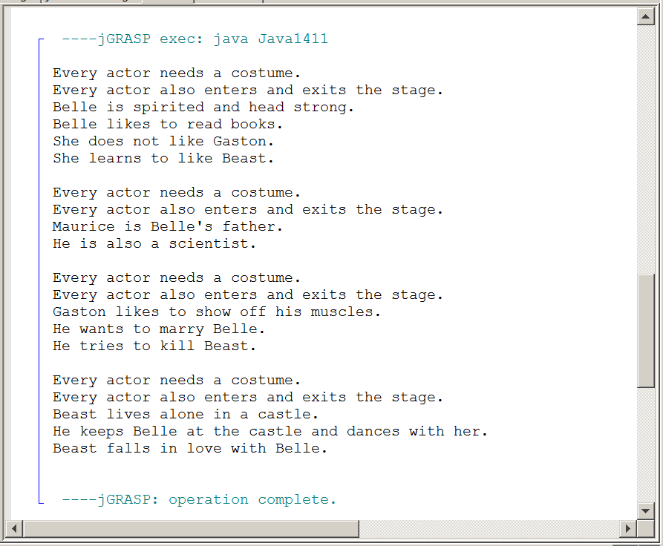

After the first two lines the output displays changes for each actor and the details that follow come from the re-definition of the act methods found in each subclass. You will see that each re-definition starts with a call to the superclass act method. Figure 14.17 shows the act re-definition of the Belle class.

Figure 14.17
public void act()
{
super.act();
System.out.println("Belle is spirited and head strong.");
System.out.println("Belle likes to read books.");
System.out.println("She does not like Gaston.");
System.out.println("She learns to like Beast.");
System.out.println();
}
Now comes a simple question. How exactly do you handle the same process of the Beauty and the Beast program with an interface umbrella? The answer is also simple. You cannot do it. In an interface the act method will be abstract and each implementing class will define the act method for the first time and every class will have to include all those common details.

Perhaps it does not seem a big concern. Keep in mind that we only showed four actors and only two details they had in common. This is not a realistic program and in the real world saving program code takes less time to create, less time to load and occupies less space in memory. It is win, win and win.

More needs to be stated about interface or superclass, but first another look at beauty and the beast to show polymorphism performed with an ArrayList object. It is a nice, elegant and practical way to make every object in a data structure perform some function according to its own definition. Java1412.java in figure 14.18 shows part of the program. The subclasses are all identical. The only concern here is the use of polymorphism with an array of Actor objects.

Figure 14.18
// Java1412.java
// The <act> method is now called from a loop that
// traverses an array with the umbrella <Actor> superclass.
import java.util.ArrayList;
public class Java1412
{
public static void main (String[ ] args)
{
ArrayList<Actor> actors = new ArrayList<Actor>();
Actor belle = new Belle();
Actor maurice = new Maurice();
Actor gaston = new Gaston();
Actor beast = new Beast();
actors.add(belle);
actors.add(maurice);
actors.add(gaston);
actors.add(beast);
for (Actor actor : actors)
actor.act();
}
}

OK, we did establish that situations exist where the interface cannot handle polymorphism as well as a superclass. Fine. How about the other way around? Are there situations where the interface is better than a superclass? Figure 14.19 shows the Language interface and its four implementing, concrete classes.

Figure 14.19
abstract interface Language
{
public abstract void greeting();
}
class English implements Language
{
public void greeting() { System.out.println("In English you say Good Day"); }
}
class German implements Language
{
public void greeting() { System.out.println("In German you say Guten Tag"); }
}
class Dutch implements Language
{
public void greeting() { System.out.println("In Dutch you say Goeden Dag"); }
}
class French implements Language
{
public void greeting() { System.out.println("In French you say Bonjour"); }
}

This is classic example where an abstract, polymorphic method is perfect. The polymorphic method is needed in the umbrella - interface or superclass - to perform polymorphism. Each subclass shows a different greeting. How about the interface? Well the interface is not a specific language. The interface exists to make this polymorphism work. This is different from an Actor superclass, which has a legitimate functionality at the superclass level used by all subclasses, before re-defining the act method. Figure 14.20 shows the same language business can be achieved with a superclass greeting method that has an empty body. I am sorry, but this is just silly. Here is where an interface is better.

Figure 14.20
class Language
{
public void greeting() { }
}
14.6 How does Polymorphism Work?

For this section I am going to borrow from my friend Dan Umbarger. Somewhere around 2007, Dan created a nice paper explaining polymorphism. He showed it to me years ago and I read it again recently in preparation for rewriting my polymorphism chapter. The statements, and some ideas, in this section are based on, and influenced by, Dan Umbarger's paper and I appreciate the work he did creating lots of good polymorphism information.

This chapter is not finished yet. There is still a case study coming to visually show polymorphism. Furthermore, much has been done to show the mechanics of polymorphism, but what about answering how this polymorphism comes about and works anyway. What makes it tick? Very good question.

Quoting directly from An Introduction to Polymorphism in Java, by Dan Umbarger, Dallas, Texas, he writes the following at the start of his paper:

The term homonym means "a word the same as another in sound and spelling but with different meaning. The term bear could be a verb (to carry a burden) or it could be a noun (a large hairy mammal). One can distinguish between the two usages through the use of context clues.

If I say a single word bear you may or may not know what I mean. This changes as I use a complete sentence and state: I cannot bear to watch the negative news anymore. This is very different from honey watch the cute bear cups on TV. In context nobody is confused.

This is a terrific example used by Dan Umbarger, because that is what happens in Java. Picture a pile of Actor objects getting added to an array. There might be as many as twenty different objects and they all fall under the Actor umbrella superclass. This means there are 20 act definitions and each one is different. What is used, to make all these objects act out? Look at figure 4.21. That short, simple loop does the job without difficulty.

Nothing in that little chunk of code gives a clue, which method definition to use. Earlier in the chapter there was a convoluted method that used a bunch of control structures like if (g instanceof English) to determine what method must be called. That is not used here. Just a short, simple, elegant loop. Get used to it, computer nerds actually call some program code elegant.

Figure 14.21
for (Actor actor : actors)
actor.act();

Earlier in the chapter some code was shown that is repeated here in figure 14.22. Four drawSquare methods are called. Same method identifier, but different signatures. Java has no problem determining which method is use. A lot happens at compile-time when source-code is translated into byte-code. For instance a statement like int x = 10; provides a memory location for variable x and after this memory location is assigned and space is allocated, the memory reference is used during execution. In other words when you see x = x + 20; after compile time, when it is time to execute, the computer sees something different, like 5f3b42c9 = 10 + 20. The same happens with methods. There are four methods called drawSquare below, but they will be connected to four different locations in memory during compile-time by a process called early-binding.

That is not the same with the act method. The computer does not know at compile-time what to do with these identically-named methods that each re-define in a different manner. Which method to use? That can only be known at run-time with a process called late-binding. The appropriate method is called in the context of the object’s class.

Figure 14.22
public void paint(Graphics g)
{
drawSquare(g);
drawSquare(g,200,300);
drawSquare(g,Color.blue,600,200);
drawSquare(g,Color.green,500,400,200);
}

The late-binding process has to do with reliability. You make each object responsible for its own actions and the decision what actions to use are made at the point when it is necessary.

Consider the following analogy. It is graduation time. Thousands of parents and family members watch the happy students graduate. Every family member expects the correct name with the correct pronunciation to be used. There is instant horror, and shame, if the name is miss-pronounced or worse the wrong name is used. Thousands of people hear the miss-pronunciation.

A very simple, but totally effective approach is used. Make each student responsible for the correct name and the correct pronunciation. As students march up to the stage each one hands an index card to the announcer. How can it be the wrong name? Nobody knows the name better than the person walking across the stage. Pronunciation issues? Also no problem. The student gives the announcer a quick sample right before announcement.

This is late-binding. The correct action is not selected until the moment it is needed. There may be many different act methods or greeting methods, as shown in this chapter. However, these methods come with an object and that object belongs to a class. The late-binding connects the method call with the proper re-definition of the method at runtime.

Polymorphism and Reliability
Now how does this polymorphic business add reliability to any program? You had accepted reliability for encapsulation and also for inheritance and composition, but polymorphism?

In a complex program with hundreds or more classes and many, many similar, but different actions it is very easy to get confused and instruct some object to behave incorrectly.

This will not happen if each object carries its own set of instructions and is told to act, to display, to compute, etc.
And this specific set of instructions is not selected until runtime when the method is called and a connection is made between the method and the class where it is re-defined in a process that is called late-binding.

Cookies and Polymorphism
In our technology world polymorphism is very much alive and few people know that it exists or how it works.

Suppose that you browse on Amazon.com and you do some searches on Star Wars movies and novels. You make no purchases and you leave the site.

A week later you return to Amazon and magically some suggestions pop up about the latest Star wars novels and newly enhanced movies you can purchase.

How does Amazon know who you are and what you like? Yes you can be a regular customer and you may have logged in, which then brings up a profile, but thousands, if not millions of customers do not immediately create a profile and use logins.

The secret is cookies. A cookie is a small file stored on your computer with some type of relevant information. You browse Amazon and Amazon checks if cookies are enabled on your computer. If so, information about your browsing habits are stored on your personal computer. Next time that you go to Amazon, your computer is checked for cookies and Bingo an appropriate suggestion about purchasing something pops up.

Consider this cookie process like method suggest and it is polymorphic according to the customer's computer. Is it reliable? You bet, because millions of people have different tastes and these individual tastes are stored on their own computer.

Incidentally, this cookie business is not something peculiar to Amazon. Many online companies use this technology. Individuals who object to this type of technology can change the settings on their computer to "disable" cookies.

14.7 The Choo-Choo Train Inheritance

There is no more new information to be presented with polymorphism, but it may well take different approaches to understand the concept. The chapter will finish with a case study that demonstrates the development of a train in many stages. And yes it will use polymorphism with lots of inheritance to accomplish its job.

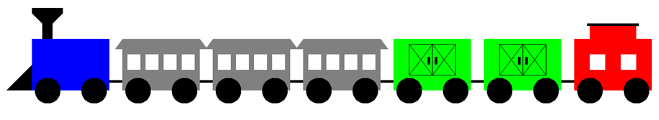

This train case study starts with a complete Choo-Choo Train picture, but that is not where the program starts. Our objective is to explain polymorphism and various techniques of inheritance using graphics. Program 1413.java, in figure 14.23, will start modestly by the display of a single railcar. It is a general railcar not yet designed for any specific train purpose.

Figure 14.23
// Java1413.java
// Train case study, Stage #1
// The first stage starts with the <RailCar> class.
// The rail car has a fixed location and position.
// Three objects all display in top of each other.
import java.awt.*;
import java.applet.*;
public class Java1413 extends Applet
{
public void paint(Graphics g)
{
RailCar rC1 = new RailCar();
RailCar rC2 = new RailCar();
RailCar rC3 = new RailCar();
rC1.drawCar(g);
rC2.drawCar(g);
rC3.drawCar(g);
}
}
class RailCar
{
private Color carColor;
public RailCar()
{
carColor = Color.blue;
}
public void drawCar(Graphics g)
{
g.setColor(carColor);
g.fillRect(325,250,150,100);
g.setColor(Color.black);
g.fillOval(330,325,50,50);
g.fillOval(420,325,50,50);
}
}

Figure 14.23 Continued
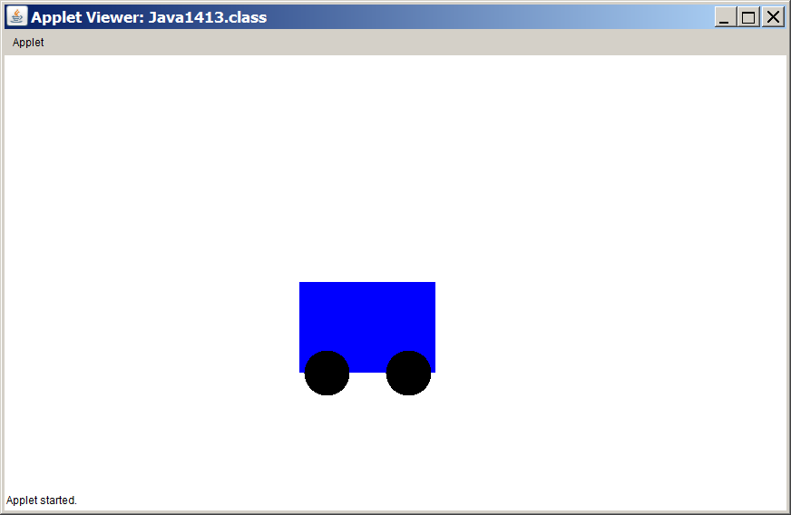

The program creates three RailCar objects and each object calls its drawCar object. Well the output only shows a single, blue railcar. Our program is not very clever. The drawCar method uses constant values and each object is drawn on top of the previous object. There are three objects, but they are not visible. This is not satisfactory. An important point is made here. Right now at the level of creating a RailCar class, decisions need to be made, because this class is going to be used later in many parts of the program. The current status is very inflexible and not at all practical for use in a bigger program.

Train Case Study, Stage #2
(Improve the RailCar)

The most important RailCar improvement is the addition of three attributes to the class, which are carColor, xPos and yPos. With these three attributes it is now possible to construct new RailCar objects with a specified color and location. This is not the only improvement. The drawCar method gets a complete overhaul using modular progframming. Separate methods are designed for the container, the wheels and the link to the next car. The secret of placing the cars correctly is to use the (xPos,yPos) coordinate point as the top-left graphics location of the RailCar object. Note in the methods that these locations are used in such a way that every car is drawn relative to the provided coordinates.

Figure 14.24
// Java1414.java
// Train case study, Stage #2
// This program improves the <RailCar> class by constructing
// new objects with a specified color and a specified location.
import java.awt.*;
import java.applet.*;
public class Java1414 extends Applet
{
public void paint(Graphics g)
{
RailCar rc1 = new RailCar(Color.blue,100,250);
RailCar rc2 = new RailCar(Color.green,275,250);
RailCar rc3 = new RailCar(Color.yellow,450,250);
RailCar rc4 = new RailCar(Color.magenta,625,250);
rc1.drawCar(g);
rc2.drawCar(g);
rc3.drawCar(g);
rc4.drawCar(g);
}
}
class RailCar
{
private Color carColor;
private int xPos;
private int yPos;
public RailCar(Color cC, int xP, int yP)
{
carColor = cC;
xPos = xP;
yPos = yP;
}
public void drawCar(Graphics g)
{
drawContainer(g);
drawRailWheels(g);
drawLink(g);
}
private void drawContainer(Graphics g)
{
g.setColor(carColor);
g.fillRect(xPos,yPos,150,100);
}
private void drawRailWheels(Graphics g)
{
g.setColor(Color.black);
g.fillOval(xPos+5,yPos+75,50,50);
g.fillOval(xPos+95,yPos+75,50,50);
}
private void drawLink(Graphics g)
{
g.setColor(Color.black);
g.fillRect(xPos-25,yPos+80,25,5);
}
}

The drawCar method is intentionally divided up into three separate methods. This provides good self-documentation, good modular programming and it makes both debugging and enhancing the program simpler. Figure 14.25 shows a lovely train of four RailCar objects. There is much to do, but it is a big improvement.

Figure 14.25
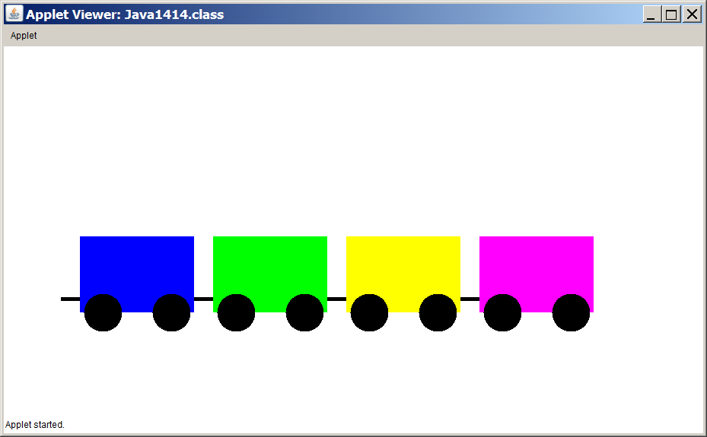
Train Case Study, Stage #3
(Create a FreightCar Class)

The RailCar class is not meant to become a car in the whole train. Its purpose it to be the common umbrella superclass for all the classes that follow. This will not only allow us to use polymorphism, but it will simplify our program code. It will help to compare a RailCar object with a FreightCar object side-by-side, which is done in figure 14.26. The container part of the two objects are the same, the wheels are the same and the link to another car is the same. This means that the RailCar class has done quite a lot of work already. The difference is that the FreightCar class adds doors to the container.

Figure 14.26
RailCar Superclass | FreightCar Subclass
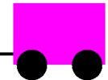 | 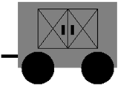

Now check out the FreightCar class in figure 14.27. It is a subclass of the RailCar superclass. It is designed with the don't reinvent the wheel philosophy. Yes, the drawCar method is re-defined, but not from scratch. The freight car is-a rail car with doors on both sides. Use that reality and start the re-defined drawCar method with a super.drawCar() call to use what is already available. This program is the first in a series that presents the different subclasses of the RailCar class. Inheritance is used, but polymorphism will still wait until all the different subclasses are shown.

Figure 14.27
// Java1415.java
// Train case study, Stage #3
// This program adds the <FreightCar> class, using inheritance.
import java.awt.*;
import java.applet.*;
public class Java1415 extends Applet
{
public void paint(Graphics g)
{
FreightCar loc = new FreightCar(Color.gray,70,250);
loc.drawCar(g);
}
}
class FreightCar extends RailCar
{
private Color carColor;
private int xPos;
private int yPos;
public FreightCar(Color cC, int xPos, int yPos)
{
super(cC,xPos,yPos);
carColor = cC;
this.xPos = xPos;
this.yPos = yPos;
}
public void drawCar(Graphics g)
{
super.drawCar(g);
drawFreightDoors(g);
}
private void drawFreightDoors(Graphics g)
{
g.setColor(Color.black);
g.drawRect(xPos+30,yPos+10,90,60);
g.drawLine(xPos+75,yPos+10,xPos+75,yPos+70);
g.drawLine(xPos+30,yPos+10,xPos+75,yPos+70);
g.drawLine(xPos+30,yPos+70,xPos+75,yPos+10);
g.drawLine(xPos+75,yPos+10,xPos+120,yPos+70);
g.drawLine(xPos+75,yPos+70,xPos+120,yPos+10);
g.fillRect(xPos+66,yPos+35,5,15);
g.fillRect(xPos+80,yPos+35,5,15);
}
}

Look at the blown-up drawCar method of the FreightCar class. It overrides the drawCar method from FreightCar, but it uses what has already been done. This pattern will happen with each subclass. First there is a call to the drawCar method of the superclass and then there is a call to the methods that finish the job of drawing the object of the subclass.

The RailCar superclass will have four subclasses: FreightCar, Locomotive, PassengerCar and Caboose. Since each one of these subclasses will be shown ahead of the program code in comparison to the RailCar display, they will not be repeated in a program output.

Train Case Study, Stage #4
(Create a Locomotive Class)

Each new subclass requires comparing the pictures. What is new? What must be added to achieve the requirements of the new class? The Locomotive is-a RailCar with a scoop and a funnel. It may seem like it is no big deal to call Super.drawCar(); It is not such a large method. Modern video game programs with sophisticated graphics are on average 500,000 lines of program code. Imagine that the video game has a superclass, called Warrior and there are 25 different types of warriors. Now also imagine that each warrior has 10 features that are identical for every warrior. That is the beauty of inheritance.

Figure 14.28
RailCar Superclass | Locomotive Subclass
 | 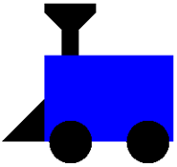

You now know the routine. The entire, functional program is shown. Much is similar and the main focus is on the new program code of the re-defined drawCar method of the Locomotive class.

Figure 14.29
// Java1416.java
// Train case study, Stage #4
// This program adds the <Locomotive> class,
// using inheritance, since a locomotive is-a railcar.
import java.awt.*;
import java.applet.*;
public class Java1416 extends Applet
{
public void paint(Graphics g)
{
Locomotive loc = new Locomotive(Color.blue,70,250);
loc.drawCar(g);
}
}
class Locomotive extends RailCar
{
private Color carColor;
private int xPos;
private int yPos;
public Locomotive(Color cC, int xPos, int yPos)
{
super(cC,xPos,yPos);
carColor = cC;
this.xPos = xPos;
this.yPos = yPos;
}
public void drawCar(Graphics g)
{
super.drawCar(g);
drawScoop(g);
drawFunnel(g);
}
private void drawScoop(Graphics g)
{
Polygon scoop = new Polygon();
scoop.addPoint(xPos,yPos+50);
scoop.addPoint(xPos,yPos+100);
scoop.addPoint(xPos-50,yPos+100);
g.setColor(Color.black);
g.fillPolygon(scoop);
}
private void drawFunnel(Graphics g)
{
Polygon funnel = new Polygon();
funnel.addPoint(xPos+20,yPos);
funnel.addPoint(xPos+20,yPos-30);
funnel.addPoint(xPos,yPos-50);
funnel.addPoint(xPos,yPos-60);
funnel.addPoint(xPos+60,yPos-60);
funnel.addPoint(xPos+60,yPos-50);
funnel.addPoint(xPos+40,yPos-30);
funnel.addPoint(xPos+40,yPos);
g.setColor(Color.black);
g.fillPolygon(funnel);
}
}

Train Case Study, Stage #5
(Create a PassengerCar Class)

Some of you may find that my train rail cars are less than artistic. Many of you can draw better images. Well, I give you a challenge. Draw some nice cars. Keep in mind that all the pictures must come from the RailCar superclass and the four subclasses each must show a picture that clearly sees the image of the RailCar. Send me the code and if I like it, I will use it in my next edition and give you and your school credit right in this chapter.

So what about the PassengerCar in figure 14.30? It has two new features. First, windows must be created in the RailCar and second, it requires a roof for greater height and provide some shade from the sun. The complete program starts in figure 14.31.

Figure 14.30
RailCar Superclass | PassengerCar Subclass
 | 

Figure 14.31
// Java1417.java
// Train case study, Stage #5
// This program adds the <PassengerCar> class,
// using inheritance, since a passenger "is-a" rail car.
import java.awt.*;
import java.applet.*;
public class Java1417 extends Applet
{
public void paint(Graphics g)
{
PassengerCar passenger = new PassengerCar(Color.green,580,250);
passenger.drawCar(g);
}
}
class PassengerCar extends RailCar
{
private Color carColor;
private int xPos;
private int yPos;
public PassengerCar(Color cC, int xPos, int yPos)
{
super(cC,xPos,yPos);
carColor = cC;
this.xPos = xPos;
this.yPos = yPos;
}
public void drawCar(Graphics g)
{
super.drawCar(g);
drawWindows(g);
drawRoof(g);
}
private void drawWindows(Graphics g)
{
g.setColor(Color.white);
g.fillRect(xPos+10,yPos+30,25,30);
g.fillRect(xPos+45,yPos+30,25,30);
g.fillRect(xPos+80,yPos+30,25,30);
g.fillRect(xPos+115,yPos+30,25,30);
}
private void drawRoof(Graphics g)
{
Polygon roof = new Polygon();
roof.addPoint(xPos-15,yPos+20);
roof.addPoint(xPos,yPos);
roof.addPoint(xPos+150,yPos);
roof.addPoint(xPos+165,yPos+20);
g.setColor(carColor);
g.fillPolygon(roof);
}
}

Train Case Study, Stage #6
(Create a Caboose Class)

Here is the final subclass of the RailCar superclass. It is appropriate since we are now looking at the Caboose class in figure 14.32. It has two windows and it has a raised roof, called a cupola, for part of the car. This It is placed at the end of a long freight train and most of the time it is colored red. Our final subclass is shown in figure 14.33.

Figure 14.32
RailCar Superclass | Caboose Subclass
 | 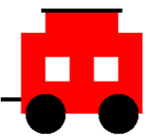

Figure 14.33
// Java1418.java
// Train case study, Stage #6
// This program adds the <Caboose> class,
// using inheritance, since a caboose "is-a" rail car.
import java.awt.*;
import java.applet.*;
public class Java1418 extends Applet
{
public void paint(Graphics g)
{
Caboose cab = new Caboose(Color.red,580,250);
cab.drawCar(g);
}
}
class Caboose extends RailCar
{
private Color carColor;
private int xPos;
private int yPos;
public Caboose(Color cC, int xPos, int yPos)
{
super(cC,xPos,yPos);
carColor = cC;
this.xPos = xPos;
this.yPos = yPos;
}
public void drawCar(Graphics g)
{
super.drawCar(g);
drawWindows(g);
drawCupola(g);
}
private void drawWindows(Graphics g)
{
g.setColor(Color.white);
g.fillRect(xPos+30,yPos+30,30,30);
g.fillRect(xPos+90,yPos+30,30,30);
}
private void drawCupola(Graphics g)
{
g.setColor(Color.red);
g.fillRect(xPos+30,yPos-30,90,30);
g.setColor(Color.black);
g.fillRect(xPos+25,yPos-30,100,5);
}
}

14.8 A Polymorphic Choo-Choo Train

The Train Case Study is coming to an end. The umbrella superclass RailCar is completed and used many times. By the way, you will probably encounter the term base class where I use umbrella. I find base-class confusing. It does not sound like the superclass. It seems more like a subclass. So I don't like to use base-class. This is OK. I am sure many people don't like my umbrella terminology. In the last section we also created four subclasses and made very good use of inheritance principles. Without actually using polymorphism, we did busily work at creating new drawCar methods for each subclass. The time has come to put this together in a complete train and use some serious polymorphism.
Train Case Study, Stage #7
(Polymorphism With a Choo-Choo Train)

Figure 14.34 shows a small program. The bigger job of creating the superclass and four subclasses has been done. In this case none of those classes will be touched, altered and even looked at right now.

Program Java1419.java tests the five classes created previously. And they will be tested by using polymorphism. We have the proper ingredients. Let's check. Check #1. We need an umbrella interface or umbrella superclass and we have that in the RailCar superclass. Check #2. We need a polymorphic method in the umbrella superclass. Check #3. We need subclasses of the umbrella superclass that re-defined (override) the polymorphic method. Now we can continue and use an array with elements of RailCar and then display every element. The output shows the result of a lovely, complete train of seven rail cars. Yes, you already know that if you dislike my train, you can send me an improved version.

Figure 14.34
// Java1419.java
// Train case study, Stage #7a
// The train case study is now ready to display.
// <RailCar> is the umbrella superclass
// and <drawCar> is the polymorphic method.
import java.awt.*;
import java.applet.*;
import java.util.ArrayList;
public class Java1419 extends Applet
{
public void paint(Graphics g)
{
ArrayList<RailCar> railCars = new ArrayList<RailCar>();
railCars.add(new Locomotive(Color.blue,100,300));
railCars.add(new PassengerCar(Color.gray,275,300));
railCars.add(new PassengerCar(Color.gray,450,300));
railCars.add(new PassengerCar(Color.gray,625,300));
railCars.add(new FreightCar(Color.green,800,300));
railCars.add(new FreightCar(Color.green,975,300));
railCars.add(new Caboose(Color.red,1150,300));
for (RailCar railCar : railCars)
railCar.drawCar(g);
}
}
Figure 14.34 Continued
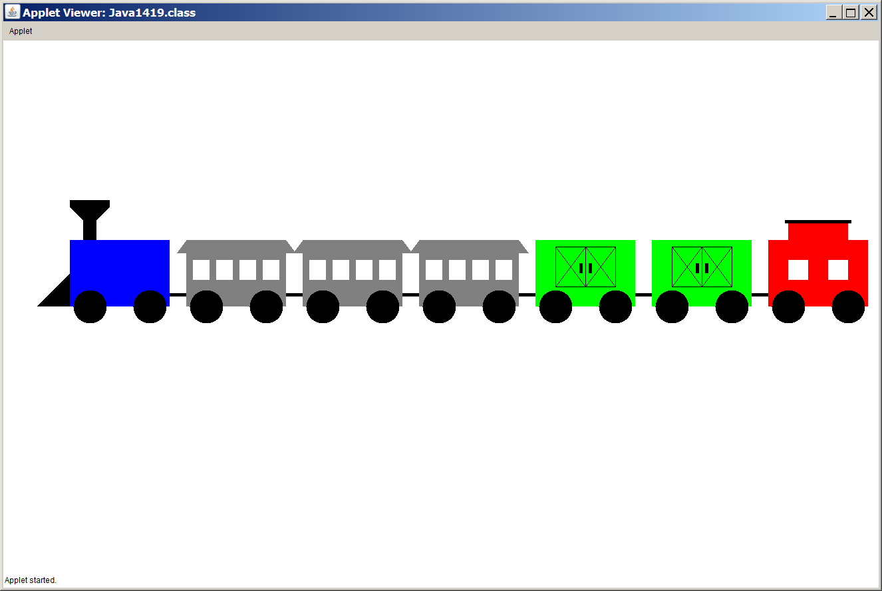

The chapter will now conclude by showing the train displayed one more time and this time with a drawTrain method that use the umbrella superclass RailCar as the data type of its parameters. That means all objects of RailCar and its subclasses are welcome to park their rail cars and get displayed.

Figure 14.36
// Java1420.java
// Train case study, Stage #7b
// All the train classes are the same in Stage #7b.
// Polymorphism is now shown with the <drawTain> method.
// The umbrella is the same <RailCar> class.
import java.awt.*;
import java.applet.*;
import java.util.ArrayList;
public class Java1420 extends Applet
{
public void paint(Graphics g)
{
RailCar railCar1 = new Locomotive(Color.blue,100,300);
RailCar railCar2 = new PassengerCar(Color.gray,275,300);
RailCar railCar3 = new PassengerCar(Color.gray,450,300);
RailCar railCar4 = new PassengerCar(Color.gray,625,300);
RailCar railCar5 = new FreightCar(Color.green,800,300);
RailCar railCar6 = new FreightCar(Color.green,975,300);
RailCar railCar7 = new Caboose(Color.red,1150,300);
drawTrain(g,railCar1);
drawTrain(g,railCar2);
drawTrain(g,railCar3);
drawTrain(g,railCar4);
drawTrain(g,railCar5);
drawTrain(g,railCar6);
drawTrain(g,railCar7);
}
public void drawTrain(Graphics g, RailCar railCar)
{
railCar.drawCar(g);
}
}

Figure 14.36 Continued
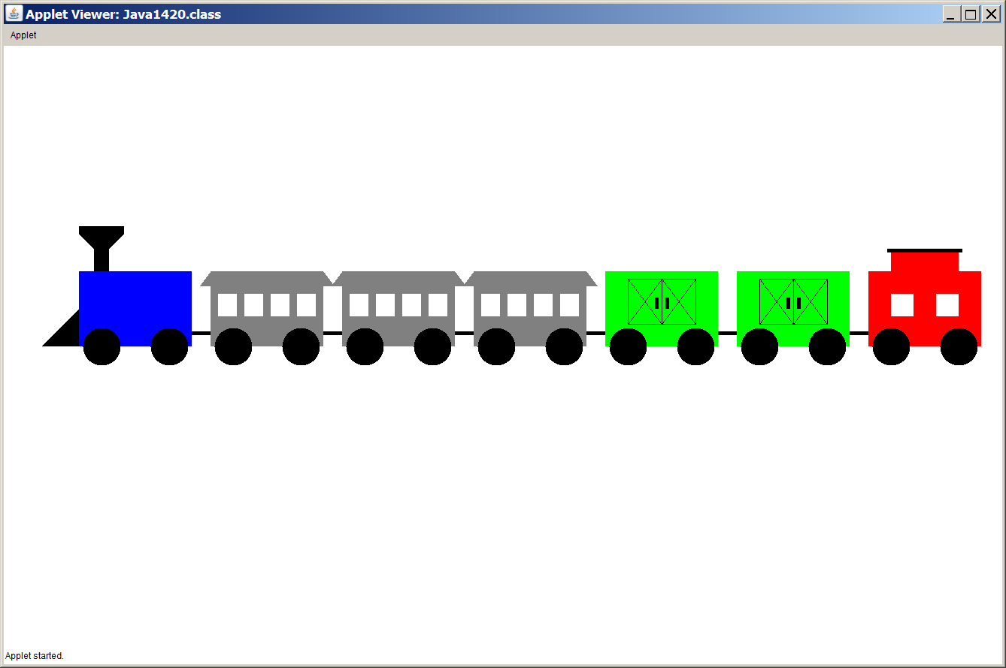

The last two program examples showed good examples of using polymorphism, but it was not good Object Oriented Programming. A group of classes were used in a testing class, but there was not proper class interaction with composition. You will visit the train classes again in a lab assignment where you create a Train class that encapsulates all the classes properly and uses proper Object Oriented Program Design.

14.9 Summary

This chapter presents the final stage in Object Oriented Programming, which is polymorphism. Polymorphism means many forms and this refers to methods that are named alike, but behave differently in objects of different classes.

The first step in polymorphism creates an umbrella interface or an umbrella superclass. In this chapter you saw the three umbrella examples of Language, Actor and RailCar.

The second step declares a polymorphic method, which will be implemented by the concrete classes, or re-defined by the subclasses. The Language interface had greeting. The Actor class used act and the RailCar class used drawCar.

In the third step each implementing concrete class or each subclass defines the polymorphic method according to its own proper functionality. It is quite possible – as happened with act and drawCar – that the polymorphic method of the superclass is used first to execute the common functionalities.

In the final step, multiple objects – many of different classes who all fall under the same umbrella – become part of a data structure with elements of the umbrella identifier, like Language, Actor or RailCar. A generic ArrayList works well for this purpose. You also saw examples where object of different classes were used in a call to a method where the formal parameter uses the umbrella data type.

Polymorphism relies on late binding. In non-polymorphic method calling, methods use early-binding at compile time. This happens with over-loaded methods. The late-binding happens at runtime when a decision is made which method version must be executed in the context of the object’s class.

